Getting Started with Course Reserves in Virgo
Reserve requests are processed in the order in which they are received. Please allow 14 days to process requests. If the library needs to recall or purchase the material, requests may take longer to fill. Although we make every effort to process requests quickly, we cannot guarantee timely service for last-minute requests. You will receive an e-mail confirmation when your reserve request has been received. Reserve requests are made by selecting items from Virgo.

Request Items for Reserve Using Virgo
- Sign into Virgo.
- Search Virgo for the materials you would like to place on reserve for your course.
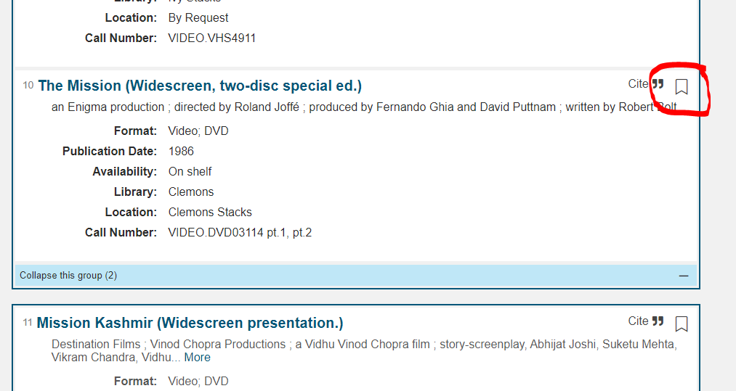
- Bookmark the items needed for reserve.
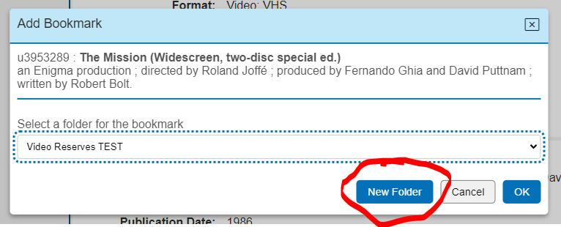
- In the resulting window, click on the New Folder button
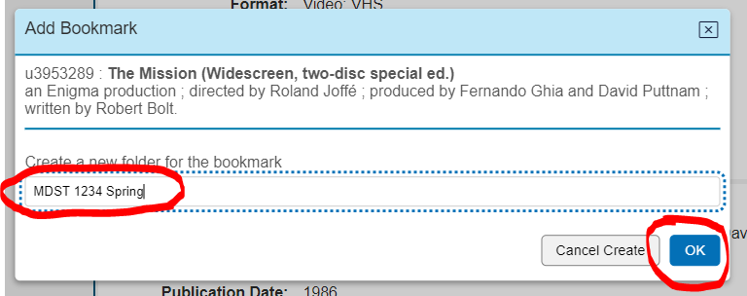
- Enter a new folder name to create a collection or select the general folder and click OK. The Course ID or title is suggested as the folder title.
- Continue searching and bookmarking until all desired items are in the folder. Folders and their contents are persistent in your account, so they can be modified and re-used.

- Select "Bookmarks" from the "Signed in as userid" drop-down menu.
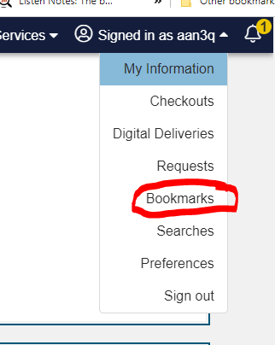

- Select the bar for the folder you want. Check ONLY the items you want to place on reserve. When complete, click on the “Place on video reserves” button.
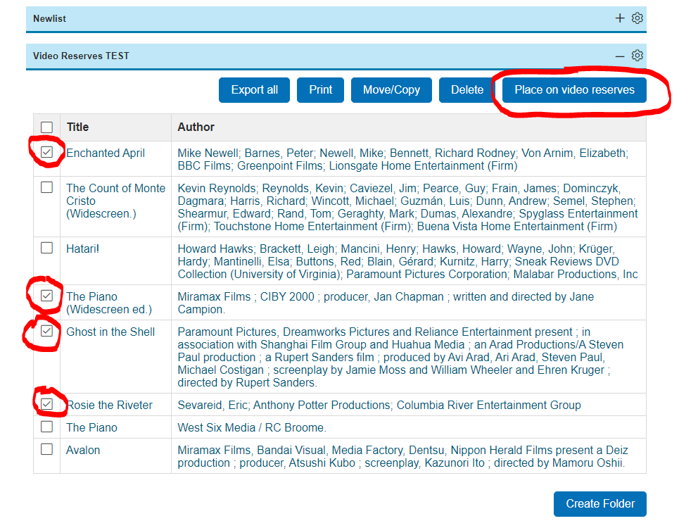

- The familiar request form will come up. Specify the course ID, the academic term, and your preferred Learning Management System. Fill in the language and subtitle fields for each film at the bottom of the form and add any relevant notes. Click “Submit Request”
